After-Action Report

Tempest’s Fury

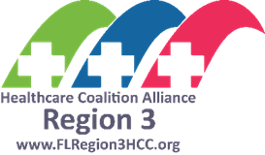
  - Gainesville -March 23, 2022
  - Saint Augustine – April 19, 2022
  - Jacksonville – April 20, 2022

The After-Action Report aligns exercise objectives with preparedness doctrine and related frameworks and guidance. Exercise information required for preparedness reporting and trend analysis is included; users are encouraged to add additional sections as needed to support their own organizational needs.

Exercise Overview

Exercise Name | Tempest’s Fury COOP Table-Top Exercise
Exercise Dates | Gainesville - March 23, 2022  Saint Augustine – April 19, 2022  Jacksonville – April 20, 2022
Scope | This was a Table-Top Exercise planned for four hours. Exercise play was limited to validating the Alliance membership Continuity of Operations (COOP) Plans across participating agencies.
Focus Area(s) | Planning, Response, Recovery
Capabilities | CDC PHEP Preparedness and Response Capabilities, Capability 2, Community Recovery, Capability 3, Emergency Operations Coordination, Capability 4; Emergency Public Information & Warning & Capability 6, Information Sharing; ASPR HC Preparedness and Response Capabilities, Capability 3, Continuity of Health Care Service Delivery
Objectives | See the table on page five of this document
Threat or Hazard | Natural / Tornadoes
Scenario | A tornado impacts the area in and around Florida Region 3. This affected Public Health and Medical facility work locations as well as homes of agency staff, which will affect the ability of the agencies to effectively carry on its functions from its primary locations.
Sponsor | Northeast Florida Regional Council
Participating Jurisdictions/ Organizations | Participants are management and staff from the various agencies across the Florida Region 3 Healthcare Coalition Alliance
Point of Contact | Name: Leigh Wilsey  Title: Healthcare Coalition Program Manager  Agency: Northeast Florida Regional Council  Phone Number: 904-279-0880 ext. 105  Email: lwilsey@NEFRC.org

EXECUTIVE SUMMARY
The Region 3 Healthcare Coalition Alliance, a program of the Northeast Florida Regional Council (NEFRC), held three 1/2-day training and exercise sessions on the following dates: March 23, April 19, and April 20, 2022. The training consisted of Just in Time Training covering Continuity of Operations Plan (COOP) awareness and terminology. A Tabletop Exercise (TTX), Tempest’s Fury, was the main focus to ascertain current operational capabilities based on established COOP plans across the broad public health and medical spectrum. Participants from over 50 Public Health and Medical facilities from multiple healthcare coalitions participated. Areas of Improvements and Strengths may not apply to each agency represented as they are trends identified across the spectrum and each agency must determine what is applicable to them.
Preparing to meet the threat of a natural disaster involves numerous parts to ensure a successful operation is completed. The following After Action Report (AAR) is intended to be a part of these ongoing efforts to build upon, as well maintain and upgrade, current capabilities. As the report is reviewed, organizations should consider the recommendations provided as suggestions to improve current operations. As this report is reviewed, the reader should understand that identified capabilities selected are twofold; 1) Assistant Secretary of Preparedness and Response (ASPR) capabilities that primarily focuses on including HCCs, hospitals, and emergency medical services (EMS) and 2) the Public Health Emergency Preparedness and Response (PHEP) capabilities which are primarily focused on State, local, tribal, and territorial public health agencies such as County Health Departments, Florida Department of Health and Emergency Support Function-8, Public Health and Medical services at the State and local levels.
Strengths
Global key strengths during the exercise included the following:
- Participants were able to identify Mission Essential Functions (MEF)s established within the COOP Plan.
- A significant number of the plans indicated clear organizational Orders of Succession, Delegation of Authority, emergency communication strategies and Alternate Facilities operations.
- Motivated participants willing to share information and contribute ideas for the good of all in attendance.
Areas for Improvement
Throughout the exercise, numerous areas of COOP improvement were identified with the key recommendations as follows:
- The #1 trend for improvement was personal preparedness. Individuals who know their loved ones are safe and secure are more able to contribute to the continuation of Mission Essential Functions.
- Provide continued COOP ongoing training for all personnel to include Senior leadership. Additionally, include cross training for all identified personnel Mission Essential Functions (MEF)s support.
- Ensure MEFs have been correctly identified and documented for each organizational facility. Validate or conduct documentation review of Mutual Aid Agreements (alternate facilities, patient transportation, fuel, personnel and critical supplies)
- Conduct annual training and exercises to validate COOP support documents, current communication capabilities and alternate facilities operations.
Throughout this document, you will find grey boxes that include instructions for completing this After-Action Report/Improvement Plan for your organization. Delete the grey boxes when you complete the After-Action Report. In addition, select the appropriate capabilities (ASPR or PHEP) that are applicable to your organization and delete the remainder.

Throughout this document you will also find highlighted text. This highlighted text should be replaced with information specific to your facility.

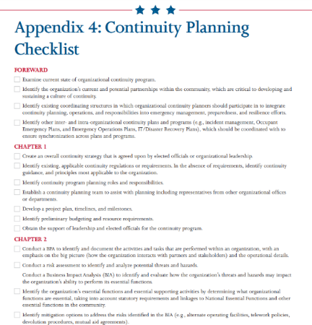
Organizations should utilize the identified improvement areas to ensure viable applications for continued operations of the facility. The COOP should be updated, and subsequent exercises completed, to test the updated plan to ensure outlined goals can be achieved. To assist in this process, organization should consider utilizing the following tools/resources in developing COOPs:
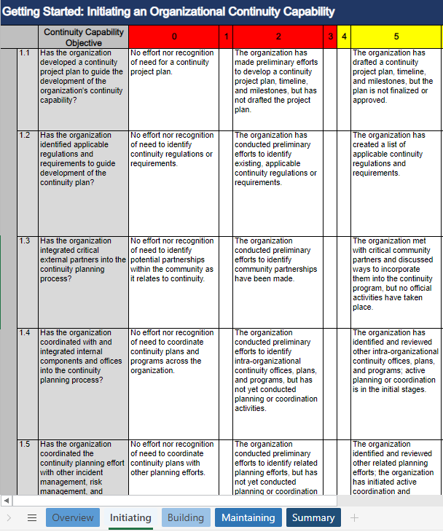
Continuity Planning Checklist
Continuity Assessment Tool:

Analysis of Capabilities
Aligning exercise objectives and capabilities provides a consistent taxonomy for evaluation that transcends individual exercises to support preparedness reporting and trend analysis. Table 1 includes the exercise objectives, aligned capabilities, and performance ratings for each capability as observed during the exercise and determined by the evaluation team.
Objective | Capability | Performed without Challenges (P) | Performed with Some Challenges (S) | Performed with Major Challenges (M) | Unable to be Performed (U)
1. Participants will identify Mission Essential Functions (MEF) and identify staff roles and responsibilities that support the Mission Essential Functions for the organization they represent | ASPR HC Preparedness and Response Capabilities, Capability 3, Continuity of Health Care Service Delivery  PHEP Preparedness and Response Capabilities, Capability 3, Emergency Operations Coordination |  | S
2. Participants will discuss the status of various Memoranda of Understanding (MOU) with appropriate outside agencies and locations. | ASPR HC Preparedness and Response Capabilities, Capability 3, Continuity of Health Care Service Delivery  PHEP Preparedness and Response Capabilities, Capability 2, Community Recovery |  |  | M
3 Participants will identify their succession plan and Delegations of Authority; listing personnel who may implement the organization’s COOP plan. | ASPR HC Preparedness and Response Capabilities, Capability 3, Continuity of Health Care Service Delivery  PHEP Preparedness and Response Capabilities, Capability 3, Emergency Operations Coordination |  | S
4. Participants will identify communications strategies and notifications | ASPR HC Preparedness and Response Capabilities, Capability 3, Continuity of Health Care Service Delivery  PHEP Preparedness and Response Capabilities, Capability 4; Emergency Public Information & Warning, Capability 2, Community Recovery & Capability 6, Information Sharing |  |  | M
5. Participants will Identify Alternate Operating Facilities. | ASPR HC Preparedness and Response Capabilities, Capability 3, Continuity of Health Care Service Delivery  PHEP Preparedness and Response Capabilities, Capability 2, Community Recovery, Capability 4, Emergency Operations Coordination | P

Table 1. Summary of Core Capability Performance
Ratings Definitions:
Performed without Challenges (P): The targets and critical tasks associated with the capability were completed in a manner that achieved the objective(s) and did not negatively impact the performance of other activities. Performance of this activity did not contribute to additional health and/or safety risks for the public or for emergency workers, and it was conducted in accordance with applicable plans, policies, procedures, regulations, and laws.
Performed with Some Challenges (S): The targets and critical tasks associated with the capability were completed in a manner that achieved the objective(s) and did not negatively impact the performance of other activities. Performance of this activity did not contribute to additional health and/or safety risks for the public or for emergency workers, and it was conducted in accordance with applicable plans, policies, procedures, regulations, and laws. However, opportunities to enhance effectiveness and/or efficiency were identified.
Performed with Major Challenges (M): The targets and critical tasks associated with the capability were completed in a manner that achieved the objective(s), but some or all of the following were observed: demonstrated performance had a negative impact on the performance of other activities; contributed to additional health and/or safety risks for the public or for emergency workers; and/or was not conducted in accordance with applicable plans, policies, procedures, regulations, and laws.
Unable to be Performed (U): The targets and critical tasks associated with the capability were not performed in a manner that achieved the objective(s).
The following sections provide an overview of the performance related to each exercise objective and associated capability, highlighting strengths and areas for improvement.

Strengths and Areas of Improvement
If you have additional strengths to note, please add lines and supporting information as needed.
If you have additional Areas for Improvement to note, please add lines and supporting information as needed. Additionally, ensure that “what was supposed to happen” and “what occurred” is accurately depicted for your organization in the following section.
Reminder to delete non-applicable capabilities ASPR vs. PHEP

OBJECTIVE 1: Participants will identify Mission Essential Functions (MEF) and identify staff roles and responsibilities that support the Mission Essential Functions for the organization they represent.
The strengths and areas for improvement for each capability aligned to this objective are described in this section.

CAPABILITIES: ASPR HC Preparedness and Response Capabilities, Capability 3, Continuity of Health Care Service Delivery; PHEP Preparedness and Response Capabilities, Capability 3, Emergency Operations Coordination

Strength 1: A vast majority of [Enter Facility Name Here] participants were familiar with Continuity of Operations concepts and operations and in several cases, their agencies Mission Essential Functions.

Areas for Improvement
The following areas require improvement to achieve the full capability level:
Area for Improvement 1: Multiple participants were not able to clearly identify Mission Essential Functions (MEFs) for [Enter Facility Name Here].

Reference: See Capabilities above, F.S.S. 381 Public Health: General Provisions, Continuity Guidance Circular 1- States, Territories, Tribal, and Local Government Jurisdictions and Private Sector Organizations
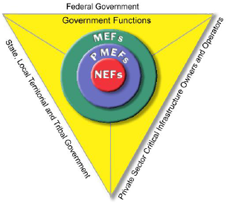
Analysis: When an event, whether natural or manmade, the Continuity of Operations Plan established by [Enter Facility Name Here] may need to be activated. Within an organizational COOP, Mission Essential Functions are the “cornerstone” for the plan and are required to be identified to ensure priority organizational operations continue to provide services needed for personnel. Proper identification of MEFs across participating personnel were murky and unable to agree upon the Mission Essential Functions necessary to be maintained upon activation of the COOP Plan. This lack of a shared common awareness is likely to cause confusion at the onset of a response to an incident requiring activation of the COOP Plan, resulting in a delayed response. It was clear that mission essential functions are not universally understood, thereby causing confusion and inefficiency in disaster response activities. FEMA Guidance indicates that non-federal entities should identify its own essential functions that in turn will align to the National Essential Functions (NEFs). [Enter Facility Name Here] will need to identify essential functions and critical services necessary to accomplish the organizational mission. Other agencies, organizations, and entities, both public and private sectors, may also find that their functions are contained within higher level essential functions and play a direct role in insuring the continuation of governmental functions.

Recommendation 1: Review [Enter Facility Name Here] COOP plan to ensure Mission Essential Functions are clearly identified and current.
- Dependent on organization MEFs may be informed by Florida Statute and/or Center for Medicare & Medicaid Services (CMS)

Recommendation 2: Brief/train all staff on the core Mission Essential Functions of their assigned agency as determined by the above.

Recommendation 3: [Enter Facility Name Here] to provide a Senior leadership COOP orientation seminar to review and confirm key COOP planning elements.

Recommendation 4: Include in position descriptions and performance reports organizational COOP responsibilities.
Recommendation 5: Conduct an agency level tabletop exercise (TTX) that includes validation of MEFs, supporting staff and other key COOP planning elements as identified in Continuity Guidance Circular -1 (CGC-1).
Recommendation 6: Following the progressive planning approach (crawl, walk, run), following execution of a TTX, conduct a full-scale exercise that includes movement, startup, as well as sustainment of an alternate facility identified in the [Enter Facility Name Here] COOP plan.

OBJECTIVE 2: Participants will discuss the status of various Memoranda of Understanding (MOU) with appropriate outside agencies and locations.
The strengths and areas for improvement for each capability aligned to this objective are described in this section.

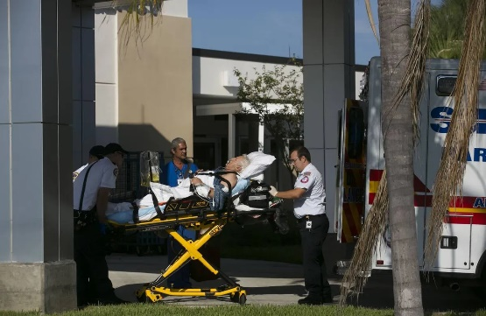
CAPABILITIES: ASPR HC Preparedness and Response Capabilities, Capability 3, Continuity of Health Care Service Delivery; PHEP Preparedness and Response Capabilities, Capability 2, Community Recovery

Strengths: None noted

Areas for Improvement
The following areas require improvement to achieve the full capability level:
Area for Improvement 1: Review and Update Current Memorandums of Understanding (MOU)s

References: ASPR HC Preparedness and Response Capabilities, Capability 3, Continuity of Health Care Service Delivery, PHEP Preparedness and Response Capabilities, Capability 2, Community Recovery, Continuity Guidance Circular, February 2018, FEMA National Continuity Programs
Analysis: [Enter Facility Name Here] should work and coordinate with other organizations and/or vendors to develop mutual aid agreements for support and assistance. Memorandums of Understanding help ensure the operations may continue at that location or others that are identified. Additionally, response and recovery operations can be initiated to further assist in organizational applications. MOUs help ensure organizations can maintain operational capability when resources the organization has applied, are exhausted. Resource requests reach the agency that can assist with the required identified need. MOUs are developed to support transportation, both private (local transportation assets) and governmental (ambulances and other associated entities), fuel supply needs as well as redundant needs to meet shortfalls and identified contingencies.

Participant feedback indicated a large portion of the organizations had developed agreements with other agencies; however, there were indications that the agreements may not fully address the needs of relocation and transportation contingencies. This was reflected as well in fuel considerations. Facilities should keep in mind that a disaster may impact local MOU suppliers and out of locality suppliers should be considered.

Recommendation 1: [Enter Facility Name Here] continuity planning teams should review all MOUs and update or create as needed. Validate or identify:
- Alternate transportation mechanisms for patient/client evacuation
- Fuel for back-up generators
- Staffing assistance
- Critical supplies/equipment
- Conduct a gap analysis
- Food and water resupply
Recommendation 2: Complete FEMA Independent Study training courses to recognize and understand the components of any Memorandum of Understanding and partnerships.
- IS-660, Introduction to Public-Private Partnerships
- IS-662, Improving Preparedness and Resilience through Public-Private Partnerships
Recommendation 3: Review MOUs annually and signed at least every other year.
OBJECTIVE 3: Participants will identify their Succession Plan and Delegations of Authority; listing personnel who may implement the organization’s COOP plan.

The strengths and areas for improvement for each capability aligned to this objective are described in this section.

CAPABILITIES: ASPR HC Preparedness and Response Capabilities, Capability 3, Continuity of Health Care Service Delivery; PHEP Preparedness and Response Capabilities, Capability 3, Emergency Operations Coordination

Strengths: None noted

Areas for Improvement
The following areas require improvement to achieve the full capability level:
Area for Improvement 1: Orders of Succession were not clearly identified.

Reference: ASPR HC Preparedness and Response Capabilities, Capability 3, Continuity of Health Care Service Delivery, PHEP Preparedness and Response Capabilities, Capability 3, Emergency Operations Coordination, Continuity Guidance Circular 1, February 2018, FEMA National Continuity Programs

Analysis: In many cases exercise participants had some difficulty identifying specific Orders of Succession. As identified in FEMA Guidance, Orders of Succession provide for the orderly and predefined assumption of senior agency offices during an emergency in the event that any officials are unavailable to execute their legal duties. “It is critical to have a clear line of succession to office established in the event leadership becomes debilitated or incapable of performing its legal and authorized duties, roles, and responsibilities. The designation as a successor enables that individual to act for and exercise the powers of a principal in the event of that principal’s death, incapacity, or resignation.” As described, these should be considered in advance, and documented, to preclude delay of decision-making. [Enter Facility Name Here], when developing these documents, should seek legal guidance to ensure applicable laws and requirements are adhered to and applied. Without a clearly identified succession plan, critical decisions regarding mission essential functions, staffing, expenditures and life safety may be put in jeopardy.

Recommendation 1: [Enter Facility Name Here] should complete an initial, as well as a recurring review (quarterly for personnel changes) of required documentation, to include legal review, to validate and enact the Orders of Succession. Include:
- The conditions under which succession will take place
- The method of notification
- Limitations on delegations of authority by successors

Recommendation 2: Conduct education sessions for individuals identified in Orders of Succession to foster expedient critical decision making.

Recommendation 3: Conduct an annual exercise that includes testing of the above-mentioned documents and the personnel identified within to ensure applicable positions can operate as intended.

Area for Improvement 2: Pre-designated Delegations of Authority were not identified.

Analysis: Delegation of Authority responsibilities, much like those of the Orders of Succession, should be developed and clearly identified in the COOP plan. Delegations of Authority are formal documents that specify the activities that those who are authorized to act on behalf of the agency head or other key officials may perform. Typically, those who are delegated roles and responsibilities serve as the backbone for [Enter Facility Name Here] operations and bear tremendous responsibility for accomplishing mission essential functions. Identification of delegations provide authorization to execute organizational requirements and specific duties; this authority is essential to the continuity program. The Delegations of Authority once developed, should be continually reviewed to ensure currency and applicable laws meet organizational and state requirements for the location in which the organization resides. This is especially relevant as we see a general uptick in staff transitions. Lack of clear lines of authority can lead to confusion and delays impacting client and staff needs.

Recommendation 1: [Enter Facility Name Here] should complete an initial and recurring review of established documents. Ensure the following elements are included:

- The authority that is being delegated, including any exceptions.
- The limits of that authority.
- To whom the authority is being delegated (by title, not name).
- The circumstances under which delegated authorities would become effective and when they would terminate.
- The successor's authority to redelegate those functions and activities.

Recommendation 2: Conduct education sessions for Individuals identified in Delegations of Authority to identify responsibilities and limitations and empower expedient action taking.

Recommendation 3: Conduct an annual exercise that includes testing of the above-mentioned documents and the personnel identified within to ensure applicable positions can operate as intended.
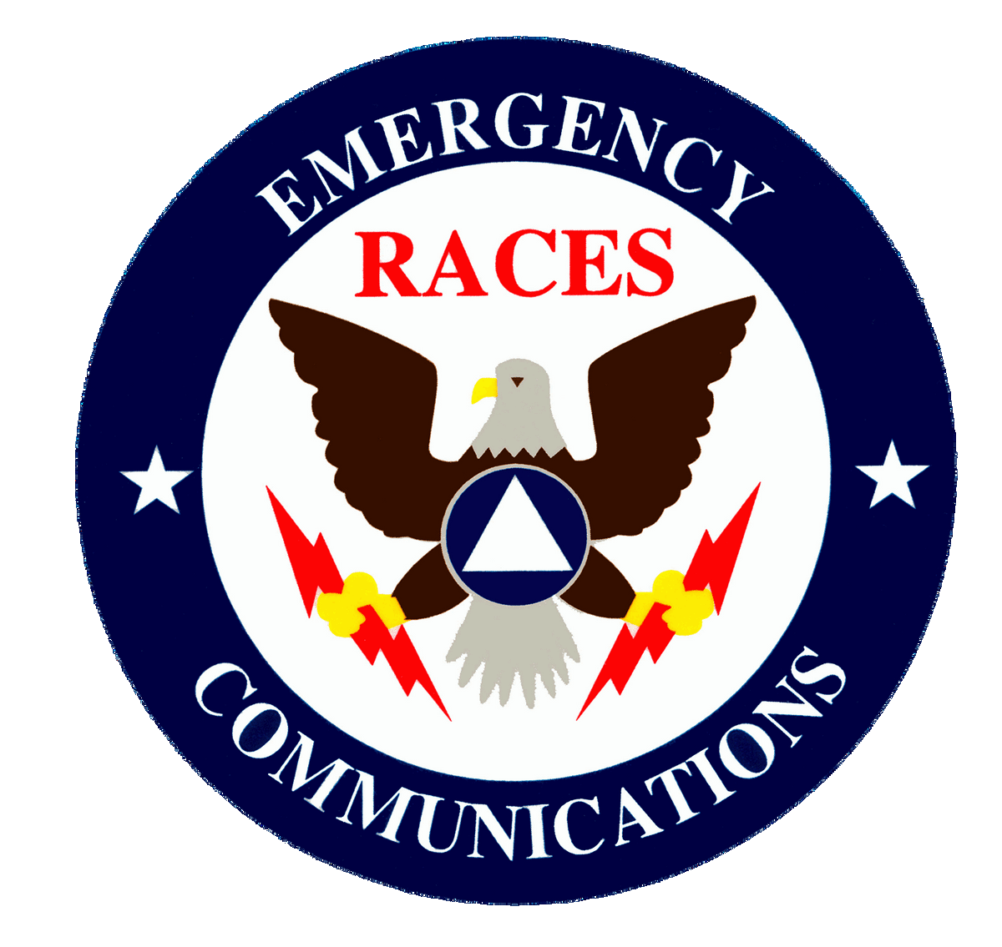

OBJECTIVE 4: Participants will identify communications strategies and notifications
The strengths and areas for improvement for each capability aligned to this objective are described in this section.

CAPABILITIES: ASPR HC Preparedness and Response Capabilities, Capability 3, Continuity of Health Care Service Delivery; PHEP Preparedness and Response Capabilities, Capability 4; Emergency Public Information & Warning, Capability 2, Community Recovery & Capability 6, Information Sharing

Strengths: None Identified

Areas for Improvement
The following areas require improvement to achieve the full capability level:
Area for Improvement 1: Methods for alerting and informing personnel.
References: FEMA Core Capabilities: Public Information and Warning, Public Health Emergency Preparedness and Response Capabilities: Capability 2: Community Recovery, Public Health Emergency Preparedness and Response Capabilities: Capability 4: Emergency Public Information and Warning
Analysis: [Enter Facility Name Here] participants struggled with initial communications, post-disaster, when traditional communications methods are unavailable as was experienced during Hurricane Michael. The COOP plan should provide a detailed set of procedures that identifies who will contact various personnel/groups within the organization. It also specifies how those contacted personnel will be provided with instructions and notifications in order to determine whether the alert or initial action procedures are triggered during duty hours or non-duty hours. While participants could not identify specific platforms, providers, vendors, or methods of information and communication transport, the anticipated available tools and approaches to communication and information exchange may be mostly dependent on the use of traditional telecommunications methods, Information Communication Technology (ICT) platforms such as Alert Notification Software/Servers, Enterprise Email Systems, and a dedicated information phone line. Damage to critical elements of one or more of these types of infrastructure, or a protracted time-to-recovery of their operational status may impede communication efforts to personnel offsite or those awaiting information during initial alert notification. This may also impede the sharing of activation procedures still to be initiated or response actions already underway. Organizations should work with and leverage the validated street address information the human resources department may already have on file for all department employees and use this to create hard copy personnel lists of groups of individuals residing within the same jurisdictions and or within similar miles of radius to create an offline data set in order to facilitate an alternate means of making contact with staff with other methods are unavailable. To address the anticipated personal privacy concerns, a viable alternative could be to identify geolocated Points of Interest as an organizational personnel rallying point (e.g., a fire station, supermarket, softball field, waffle house or gas station) that is centrally located amongst a disparate group of personnel who live within a specific milage radius of each other, without the need to fully disclose all individuals’ personal address information. For increased redundancy, locations should all be translated into their raw latitude and longitude coordinates (in case roadway and or street signage is destroyed - potentially debilitating or causing critical errors in modern street mapping/navigation systems). This offline information communication tool can be made available as part of a standard situational awareness and communications posture in advance of any emergency event, provided in paper-based format and disseminated to all key points of contact residing within specific miles radius or cardinal points of each unique jurisdictional area grouping. This addition could help facilitate and enhance the ability for physical contact and communication attempts with personnel who may be cut off or encountering severe disruptions from traditional telecomms and ICT methods of alert, notification, and information sharing. Multiple exercise participants expressed concerns related to the current communications processes as indicated in the exercise Participant Feedback Forms and information exchange with exercise facilitators.
Recommendation 1: Create a geocoded dataset /spreadsheet of [Enter Facility Name Here] personnel residences and identify centralized and cardinal points of interest (POI) to serve as rallying locations in case of loss of telecomms and ICT. Ensure the rallying points information is produced in paper copy for offline use and distributed to personnel.
- Form a Working Group with [Enter Facility Name Here] Human Resources to validate the information against HR official personnel file data.
- Extract current personnel geolocation information from the organization as listed in the existing Alert Notification System (if any).
Recommendation 2: Draft a procedure that defines the trigger(s) for when, where and how [Enter Facility Name Here] personnel should utilize the rallying point document in order to make the determination of when to commence travel to which of the identified/designated POI.
Recommendation 3: Coalitions to consider cost-sharing a mass notification system (Everbridge as an example amongst others) that are able to send messages by designated/assigned groups using various user identified communications such as phone, text and email.
Area for Improvement 2: Amateur Radio Services
References: FEMA Core Capabilities: Public Information and Warning, Public Health Emergency Preparedness and Response Capabilities: Capability 2: Community Recovery, Public Health Emergency Preparedness and Response Capabilities: Capability 4: Emergency Public Information and Warning
Analysis: FEMA Guidance indicates: “The success of continuity programs is dependent on the availability of and access to communications systems with sufficient resiliency, redundancy, and accessibility available to perform essential functions and provide critical services during a disruption”. Without the ability to communicate both internally and externally when a disaster occurs, [Enter Facility Name Here] abilities to complete the identified essential mission requirement will be either seriously degraded or impossible to complete. As witnessed in multiple disasters, immediately post-disaster traditional communications may be initially unavailable - just when needed most- and may be down from hours to days. Amateur radio services may be a “bridging” element until traditional services can be restored.
Recommendation 1: Engage local amateur radio providers such as the North Florida Radio Society or the Amateur Radio Emergency Service to assist with emergency communications:
- Invite amateur radio providers to inform organizations during Healthcare Coalition Meetings
- Identify availability to support Alliance members during disasters
- Identify training and equipment needed for organizational self-sustainment

OBJECTIVE 5: Participants will Identify Alternate Operating Facilities.

The strengths and areas for improvement for each capability aligned to this objective are described in this section.

CAPABILITIES: ASPR HC Preparedness and Response Capabilities, Capability 3, Continuity of Health Care Service Delivery; PHEP Preparedness and Response Capabilities, Capability 2, Community Recovery, Capability 4, Emergency Operations Coordination

Strengths
Strength: Participant feedback indicated that 88% of the organization COOPs had Alternate Facilities identified.

Areas for Improvement:
The following areas require improvement to achieve the full capability level:

Areas for Improvement 1: Alternate Operating Locations
Reference: ASPR HC Preparedness and Response Capabilities, Capability 3, Continuity of Health Care Service Delivery, PHEP Preparedness and Response Capabilities, Capability 2, Community Recovery, Capability 4, Emergency Operations Coordination, Continuity Guidance Circular, February 2018, FEMA National Continuity Programs

Analysis: Participant feedback, as well as evaluator observations, indicated that [Enter Facility Name Here] COOPs did not have Alternate Facilities identified. Alternate sites consideration should meet the needs of the site that is being evacuated and support the continuation of Mission Essential Functions. Participants indicated that one of the largest concerns included assurance that alternate sites could be adapted to the patient load when activated. This would also include the ability to operate with the identified needs for the evacuating facility. When considering these facilities, people with special needs and/or disabilities should be a major consideration for use. Sites should not be in the local area, if possible, as they may be damaged as well and not be habitable for individuals. FEMA Guidance classifies alternate sites for alternate facilities in to three different types:

- Hot Sites: These types of sites are fully established and have all the identified infrastructure and equipment to support operations.
- Warm Sites: These types of sites will have some of the necessary equipment and facility accommodation that may be needed to support operations.
- Cold Site: These types of sites are not normally manned by any personnel on a daily basis and may need equipment to be brought in to support the facility.
The site(s) chosen should ensure they can accommodate current operational loads as well as possible surge capacity.

Recommendation 1: Review alternate and tertiary locations to ensure at a minimum:
- Site locations allow for the execution of Mission Essential Functions
- Site locations can support patients/clients along with critical staffing requirements
- Communications and internet connectivity is available
- Locations selected are outside anticipated disaster zones
- Consider MEFs that can be accomplished via telework

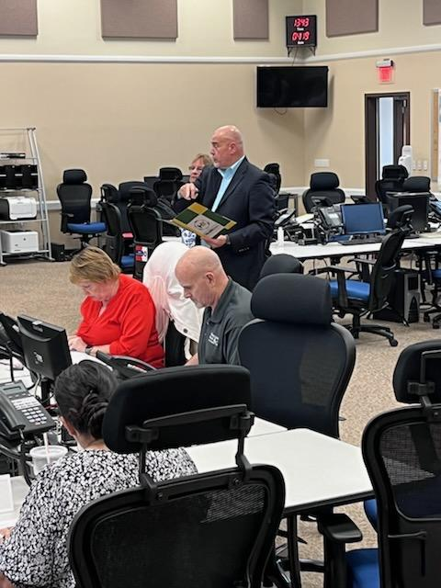
Additional Observations: The Evaluation Team or participants provided additional feedback on items that should be considered in order to improve the continuity of operations capability.
Area for Improvement 1: Personal Preparedness Training
Reference: ASPR HC Preparedness and Response Capabilities, Capability 3, Continuity of Health Care Service Delivery; PHEP Preparedness and Response Capabilities, Capability 2, Community Recovery, Capability 4, Emergency Operations Coordination

Analysis: When an incident occurs which necessitates the need to implement the Continuity of Operations Plan (COOP), staff must be prepared to execute the continuation of MEFs. It became evident to the evaluation team that there was no consistency in personal preparedness training in the event of disaster. Staff that are not prepared in the event of a disaster may impede the continuation of mission essential functions, cause unintentional harm to patients, delay continuity of care and contribute to unmet needs.

Recommendation: [Enter Facility Name Here]/NEFRC develop a Personal Preparedness Awareness Training course that can be delivered a: In-Person; B) Virtually and/or; C) On-Demand. Resources to support this recommendation can be found at FEMA’s OPEN or Ready websites. Consider including:
- Family care plan to include children and elderly
- Pet care plan
- Communications
- Medications
- Financial preparedness
- Evacuation
- Safety Skills
- Go-Bags

Area for Improvement 2: Post-Traumatic Stress Disorder (PTSD) Awareness Training
Reference: ASPR HC Preparedness and Response Capabilities, Capability 3, Continuity of Health Care Service Delivery; PHEP Preparedness and Response Capabilities, Capability 2, Community Recovery, Capability 4, Emergency Operations Coordination

Analysis: It was evident during all sessions that participants were very focused on the exercise section that introduced staff members to those who were demonstrating effects of PTSD. Staff with PTSD may relive the event via intrusive memories, flashbacks, and nightmares; avoid anything that reminds them of the trauma; and have anxious feelings they didn’t have before that are so intense their lives are disrupted. These cases are not limited to military members who have served during conflict. Staff who have PTSD may have debilitating symptoms and find it difficult to maintain job responsibilities.

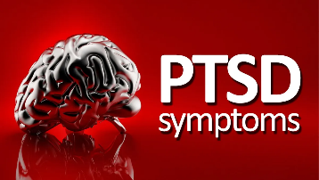
Recommendation: [Enter Facility Name Here]/NEFRC develop a Post-Traumatic Stress Disorder Awareness Training course that can be delivered A): In-Person; B) Virtually and/or; C) On-Demand. If available within the Alliance, leverage existing mental health partners to aid in informing coalition agency members. Consider including:
- Identification of signs or symptoms
- Employee Assistance Programs
- Local programs
- What to do

Area for Improvement 3: Continuity of Operations Awareness Training
Reference: ASPR HC Preparedness and Response Capabilities, Capability 3, Continuity of Health Care Service Delivery; PHEP Preparedness and Response Capabilities, Capability 2, Community Recovery, Capability 4, Emergency Operations Coordination

Analysis: Multiple exercise participants acknowledged that they weren’t as familiar with the [Enter Facility Name Here] COOP program, in general, as they would like to be. Advancing the knowledge of staff members of COOP will elevate the preparedness level overall for each organization. Annual refresher training, periodic plan reviews/updates and exercising individual COOP plans will aid in recognition primed decision making – or building “muscle memory”.

Recommendation 1: [Enter Facility Name Here] present an orientation to all staff on generic COOP planning elements (at the “awareness” level) along with organizational specific elements. These awareness sessions may be included during staff or town hall meetings. Staff members may also access FEMA’s Independent Study Course IS—1300, Introduction to Continuity of Operations.

Area for Improvement 4: Continuity of Operations Staff - Force Multiplier
Reference: ASPR HC Preparedness and Response Capabilities, Capability 3, Continuity of Health Care Service Delivery; PHEP Preparedness and Response Capabilities, Capability 2, Community Recovery, Capability 4, Emergency Operations Coordination

Analysis: On multiple occasions [Enter Facility Name Here] participants have identified a shortage of supporting staff members. Staffing shortages nationwide have been documented as the “Great American Walkout” and the reasons for the walkout may be wide and varied but can have real impacts on those providers in the Public Health and Medical industries. Where possible, a good policy is to identify staff members “Three Deep” for contingency operations which gives some measure of confidence in terms of the continuation of Mission Essential Functions. Inability to staff critical positions can put the Executive Team in the position of determining which MEFS will need to be put on hold until staff is available to undertake them.

Recommendations:

- Identify (where possible), unassigned staff members to ensure each critical function is manned “Three Deep”
- Train newly assigned staff on COOP related roles and responsibilities
- Conduct exercises on a periodic basis to maintain skillsets
Area for Improvement 5: Local EOC Support and Awareness
Reference: ASPR HC Preparedness and Response Capabilities, Capability 3, Continuity of Health Care Service Delivery; PHEP Preparedness and Response Capabilities, Capability 2, Community Recovery, Capability 4, Emergency Operations Coordination

Analysis: As been stated over and over, “The time to exchange business cards is not during a disaster”. Multiple participants, while generally aware of what an Emergency Operations Center is, did not know some of the inner workings that may enhance their ability to survive and operate. Some were ready to buckle down and wait for the cavalry to come in, but who was calling the cavalry? Largely participants were unaware of Emergency Support Function -8, Public Health and Medical Services and their role within the local EOC. They were unaware that ESF-8 can aid, in certain circumstances, with supply, logistics and potentially manpower support. While a temporary solution to address immediate needs, not knowing of this capability may impede critical care to patients.
Recommendations:
- Include in relevant plans the process to contact the EOC and/or ESF8 and how to request support
- Receive an organizational briefing from ESF-8 on local capabilities and process for key staff members
Area for Improvement 6: Additional Training Needs
Reference: Multiple

Analysis: Exercise facilitators encouraged exercise players to identify additional training needs which would further their preparedness efforts and aid the NEFRC in further assisting members of the Alliance. While identified training may not be aligned directly with Continuity of Operations, they can be contributing elements to COOP success:
- Amateur Radio Licensing
- Active Assailant Training
- Incident Command System
- Shelter Training
- Family Reunification
- Disaster Planning
- Communication Methodologies

Recommendations:

- Conduct a Training Needs Assessment and prioritize training based on priority across the Alliance
- Include in upcoming Integrated Preparedness Plans
- Deliver training as identified and funded

- Improvement Plan
Capability | Issue/Area for Improvement | Corrective Action | Capability Element | Primary Responsible Organization | Organization POC | Start Date | Completion Date
ASPR HC Preparedness and Response Capabilities, Capability 3, Continuity of Health Care Service Delivery; PHEP Preparedness and Response Capabilities, Capability 3, Emergency Operations Coordination | 1 Mission Essential Functions (MEFs) Identification | Review [Enter Facility Name Here] COOP plan to ensure Mission Essential Functions are clearly identified and current | Planning
 |  | Brief/train all staff on the core Mission Essential Functions of their assigned agency as determined by the above. | Training
 |  | Provide [Enter Facility Name Here] Senior leadership COOP orientation seminar to review and confirm key COOP planning elements. | Training
 |  | Include in position descriptions and performance reports [Enter Facility Name Here] COOP responsibilities. | Planning
 |  | Conduct an agency level tabletop exercise (TTX) that includes validation of MEFs, supporting staff and other key COOP planning elements as identified in CGC 1. | Exercise
 |  | Following the progressive planning approach (crawl, walk, run), following execution of a TTX, conduct a full-scale exercise that includes movement and startup as well as sustainment of an alternate facility identified in the organizational COOP plan. | Exercise
ASPR HC Preparedness and Response Capabilities, Capability 3, Continuity of Health Care Service Delivery; PHEP Preparedness and Response Capabilities, Capability 2, Community Recovery | 1. Review and Update Current Memorandums of Understanding (MOU)s/Mutual Aid Agreements (MAAs) | Review all MOUs and update or create as needed, validate/identify:  • Alternate transportation mechanisms for patient/client evacuation  • Fuel for back-up generators  • Staffing assistance  • Critical supplies/equipment  • Conduct a gap analysis  • Food and water resupply | Planning
 |  | Complete FEMA Independent Study training courses:  • IS-660, Introduction to Public-Private Partnerships  • IS-662, Improving Preparedness and Resilience through Public-Private Partnerships | Training
 |  | Review MOUs annually and signed at least every other year. | Planning
ASPR HC Preparedness and Response Capabilities, Capability 3, Continuity of Health Care Service Delivery; PHEP Preparedness and Response Capabilities, Capability 3, Emergency Operations Coordination | 1. Orders of Succession were not clearly identified. | [Enter Facility Name Here] should complete an initial, as well as a recurring review (quarterly for personnel changes) of required documentation, to include legal review, to validate and enact the Orders of Succession. Include:  • The conditions under which succession will take place  • The method of notification  • Limitations on delegations of authority by successors | Planning
 |  | Conduct education sessions for Individuals identified in Orders of Succession to foster expedient critical decision making. | Training
 |  | Conduct an annual exercise that includes testing of the above-mentioned documents and the personnel identified within to ensure applicable positions can operate as intended. | Exercise
 | 2. Pre-designated Delegations of Authority were not identified. | Complete an initial and recurring review of established documents. Ensure the following elements are included:  • The authority that is being delegated, including any exceptions.  • The limits of that authority.  • To whom the authority is being delegated (by title, not name).  • The circumstances under which delegated authorities would become effective and when they would terminate.  • The successor's authority to redelegate those functions and activities. | Planning
 |  | Conduct education sessions for Individuals identified in Delegations of Authority to identify responsibilities and limitations and empower expedient action taking. | Training
 |  | Conduct an annual exercise that includes testing of the above-mentioned documents and the personnel identified within to ensure applicable positions can operate as intended. | Exercise
ASPR HC Preparedness and Response Capabilities, Capability 3, Continuity of Health Care Service Delivery; PHEP Preparedness and Response Capabilities, Capability 4; Emergency Public Information & Warning, Capability 2, Community Recovery & Capability 6, Information Sharing | 1. Methods for alerting and informing personnel. | Create a geocoded dataset /spreadsheet of organizational personnel residences and identify centralized and cardinal points of interest (POI) to serve as rallying locations in case of loss of telecomms and ICT. Ensure the rallying points information is produced in paper copy for offline use and distributed to personnel.  • Form a Working Group with local Human Resources to validate the information against HR official personnel file data.  • Extract current personnel geolocation information from the organization as listed in the existing Alert Notification System (if any). | Organizing/Planning
 |  | Draft a procedure that defines the trigger(s) for when, where and how [Enter Facility Name Here] personnel should utilize the rallying point document in order to make the determination of when to commence travel to which of the identified/designated POI. | Planning
 |  | Coalitions to consider cost-sharing a mass notification system (Everbridge as an example amongst others) that are able to send messages by designated/assigned groups using various user identified communications such as phone, text and email. | Organizing/Planning
 | 2. Amateur Radio Services | Engage local amateur radio providers such as the North Florida Radio Society or the Amateur Radio Emergency Service to assist with emergency communications:  • Invite amateur radio providers to inform organizations during Healthcare Coalition Meetings  • Identify availability to support Alliance members during disasters  • Identify training and equipment needed for organizational self-sustainment | Organizing/Planning
ASPR HC Preparedness and Response Capabilities, Capability 3, Continuity of Health Care Service Delivery; PHEP Preparedness and Response Capabilities, Capability 2, Community Recovery, Capability 4, Emergency Operations Coordination | 1. Alternate Operating Locations | Review alternate and tertiary locations to ensure at a minimum:  • Site locations allow for the execution of Mission Essential Functions  • Site locations can support patients/clients along with critical staffing requirements  • Communications and internet connectivity is available  • Locations selected are outside anticipated disaster zones  • Consider MEFs that can be accomplished via telework | Planning
ASPR HC Preparedness and Response Capabilities, Capability 3, Continuity of Health Care Service Delivery; PHEP Preparedness and Response Capabilities, Capability 2, Community Recovery, Capability 4, Emergency Operations Coordination | 1. Personal Preparedness Training | [Enter Facility Name Here] develop a Personal Preparedness Awareness Training course that can be delivered a: In-Person; B) Virtually and/or; C) On-Demand. | Training
 | 2. Post-Traumatic Stress Disorder (PTSD) Awareness Training | [Enter Facility Name Here] develop a Post-Traumatic Stress Disorder Awareness Training course that can be delivered A): In-Person; B) Virtually and/or; C) On-Demand. | Training
 | 3. Continuity of Operations Awareness Training | [Enter Facility Name Here] present an orientation to all staff on generic COOP planning elements (at the “awareness” level) along with organizational specific elements. These awareness sessions may be included during staff or town hall meetings. Staff members may also access FEMA’s Independent Study Course IS—2300, Introduction to Continuity of Operations. | Training
 | Continuity of Operations Staff - Force Multiplier | Identify (where possible), unassigned staff members to ensure each critical function is manned “Three Deep” | Organizing
 |  | Train newly assigned staff on COOP related roles and responsibilities | Training
 |  | Conduct exercises on a periodic basis to maintain skillsets | Exercise
 | Local EOC Support and Awareness | Include in relevant plans the process to contact the EOC and/or ESF8 and how to request support | Organizing/Planning
 |  | Receive an organizational briefing from ESF-8 on local capabilities and process for key staff members | Organizing/Planning
 | Additional Training Needs | Conduct a Training Needs Assessment and prioritize training based on priority across the Alliance and include in Integrated Preparedness Plan | Planning
 |  | Deliver training as identified and funded | Training
This IP is developed specifically for the Florida Region 3 Healthcare Coalition Alliance as a result of the Tempest’s Fury discussion-based exercise series conducted in the Spring of 2022.
A-11

Appendix B: Exercise Participants
Participating Organizations
A Care Connection Home Health
Apex Home Health
Ascension St Vincent’s
Ascension St Vincent’s Southside
Ascension St Vincent’s St. Johns County
Baptist Health
Baptist Medical Center Beaches
Borland Groover
Brooks Rehabilitation
Child Life Disaster Relief
Citadel
Citadel at Flagler Health and Rehab
Community Home Health Care
DCI East Gainesville
DCI West Clinic
Dialysis Clinic Inc
Epic Recovery Center (Epic Behavioral Health)
FDEM
FDOH – Columbia/Hamilton
Fernandina Beach Rehab and Nursing Center

Five Oaks Rest Home
Flagler Hospital
Florida Dept of Health – Gilchrist
Florida Dept of Health – Levy
Florida Dept of Health – Bureau of Vital Statistics
Fouraker Hills Rehab & Nursing
Fresenius Medical Care of North America
Gainesville Health and Rehabilitation Center
Hawthorne Center for Rehabilitation and Healing of Ocala
HCA Florida Putnam
Jacksonville Surgery Center
JFRD
Lake Butler Hospital
Mayo Clinic
NEFRC
Oak Hammock at the University of Florida
Orange Park Center for Nursing and Healing
Orange Park Medical Center
Parkside Surgery Center
Plaza Health & Rehab
Ponce Therapy Care Center
ProMedica/Heartland Hospice
Putnam Community Medical Center LLC
River City Surgery Center
Riverwood Center
Signature Healthcare of Middleburg
SJC Department of Health
Southern Healthcare Management
St. Augustine Endoscopy Center
St. Johns County Emergency Management
UF Health – Safety
University Center for Nursing and Healing
Westminster Woods on Julington Creek

Exercise Sponsors:

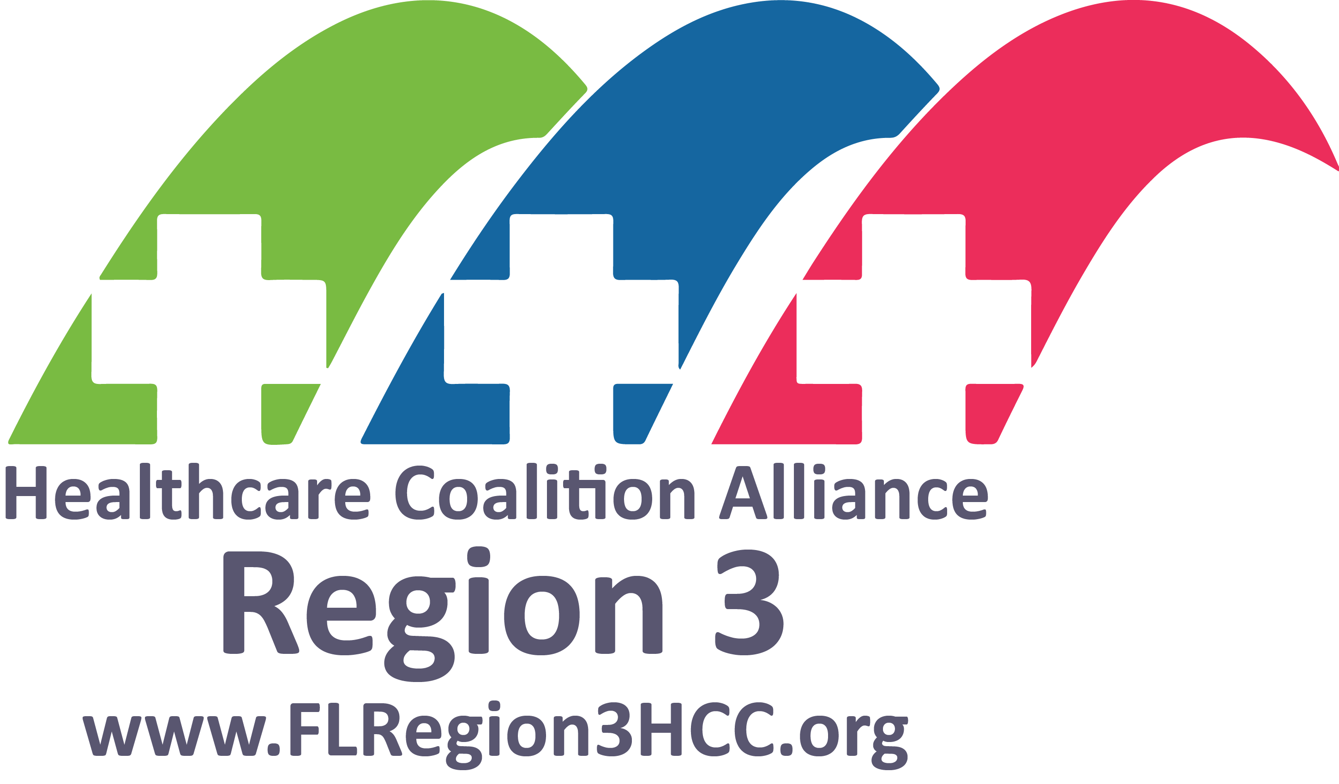

Exercise Design, Development and Facilitation Provided By:

